SIMATS ENGINEERING
ASSESSMENT TOOL 2

COURSE NAME: Database Management Systems
COURSE CODE: CSA05

COURSE OUTCOME COVERED

CO2: Apply the relational model, relational algebra, SQL query structures, and views to solve database querying and data manipulation problems. (BL3, BL6)

Activity Tool : Scenario-Based Task (Medium)
Assessment Tool Weightage: 20%

QUESTIONS
Q.No | Question | Bloom's Level
1 | A university stores student and course data in a single table. Analyze the structure and identify normalization issues, then redesign it up to 3NF | . BL4 – Analyze
2 | A company database contains employee and department details. Design appropriate SQL queries to retrieve employees working in multiple departments and justify your approach | . BL6 – Create
3 | Given a relation with multiple functional dependencies, determine the candidate keys and check whether the relation satisfies BCNF. If not, decompose it. | BL5 – Evaluate
4 | A banking system requires secure data access. Design views and constraints to ensure data security and integrity for different types of users. | BL6 – Create
5 | A sales database contains redundant data leading to anomalies. Analyze the schema and apply normalization up to 3NF or BCNF to eliminate redundancy. | BL4 – Analyze
6 | Given a dataset of customers and orders, write SQL queries using joins and subqueries to retrieve meaningful information such as frequent customers. | BL3 – Apply
7 | A relation contains multi-valued dependencies. Analyze the structure and decompose it into 4NF, explaining the reasoning. | BL4 – Analyze
8 | A database designer used improper constraints, leading to inconsistent data. Evaluate the schema and suggest appropriate integrity constraints. | BL5 – Evaluate
9 | For a given relational schema, analyze the presence of join dependencies and decompose it into 5NF to remove redundancy. | BL6 – Create
10 | A system uses inefficient SQL queries for data retrieval. Analyze the queries and optimize them using joins, indexing concepts, or query restructuring. | BL5 – Evaluate

Code of Conduct:

I DARSHINIE KARANI.V.M(192520033) (Name / Reg No) certify that this submission is my original work and that I have adhered to the guidelines specified for this assessment.
I understand that any violation of academic integrity rules will result in disciplinary action.

Signature of the student:

ANSWERS:

- Unnormalized Table (UNF) :

StudentID | StudentName | CourseID | CourseName | Faculty | Department
101 | Rahul | C101 | Bioinformatics | Dr. Kumar | Biotechnology
102 | Priya | C102 | Biotechnology | Dr. Meena | Biotechnology
103 | Arun | C101 | Bioinformatics | Dr. Kumar | Biotechnology
These are the when the datas aren’t normalised:

- Course name, faculty, and department are repeated for every student enrolled in the same course.
- If the last student enrolled in a course is deleted, the course information is also lost.

First Normal Form (1NF)
Each column contains only atomic values.
STUDENT_COURSE
| StudentID | StudentName | CourseID | CourseName | Faculty | Department |

Second Normal Form (2NF)
Remove partial dependencies by separating student and course details.

Student
StudentID | StudentName | CourseID
101 | Rahul | C101
102 | Priya | C102
103 | Arun | C101
Course
CourseID | CourseName | Faculty | Department
C101 | Bioinformatics | Dr. Kumar | Biotechnology
C102 | Biotechnology | Dr. Meena | Biotechnology

Third Normal Form (3NF)
Remove transitive dependencies by separating department information.

STUDENT
| StudentID | StudentName | CourseID |

COURSE
| CourseID | CourseName | Faculty | DepartmentID |

DEPARTMENT
DepartmentID | DepartmentName
D01 | Biotechnology
Final 3NF Schema
STUDENT(StudentID, StudentName, CourseID)

COURSE(CourseID, CourseName, Faculty, DepartmentID)

DEPARTMENT(DepartmentID, DepartmentName)

Conclusion
After normalization to 3NF:
- Data redundancy is eliminated.
- Update, insertion, and deletion anomalies are removed.
- Data integrity is improved.
- The database is easier to maintain and more efficient.
2.
EMPLOYEE
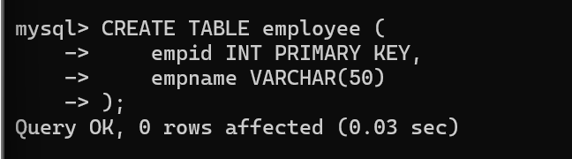

DEPARTMENT
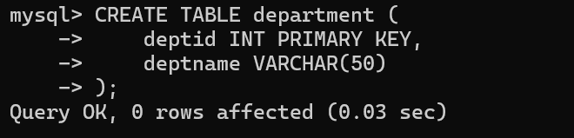
SHOW TABLES
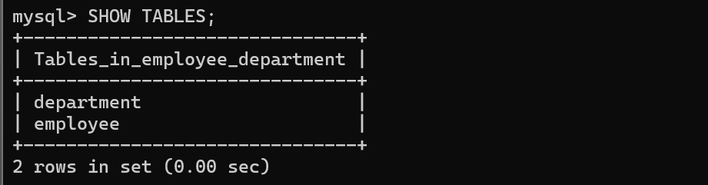
EMPLOYEE_DEPARTMENT
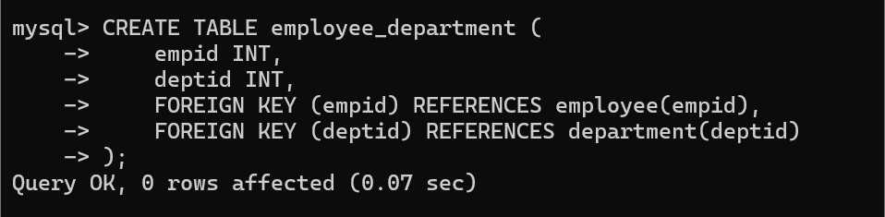
INSERTING THE DATAS INTO THE TABLES
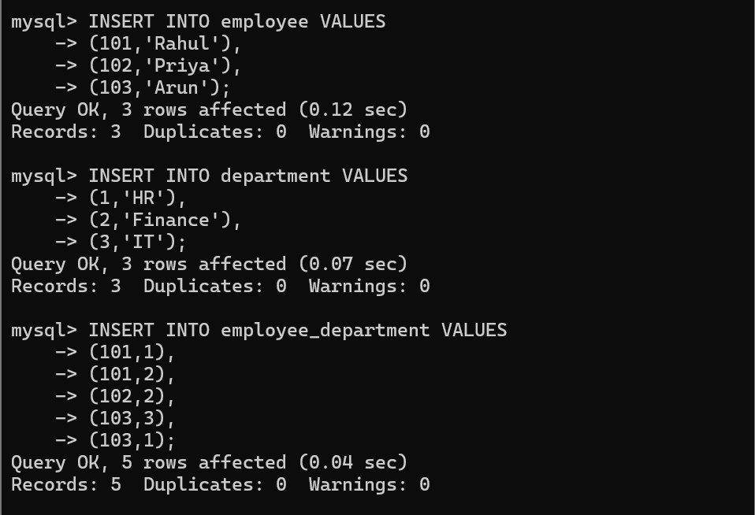
SQL Query
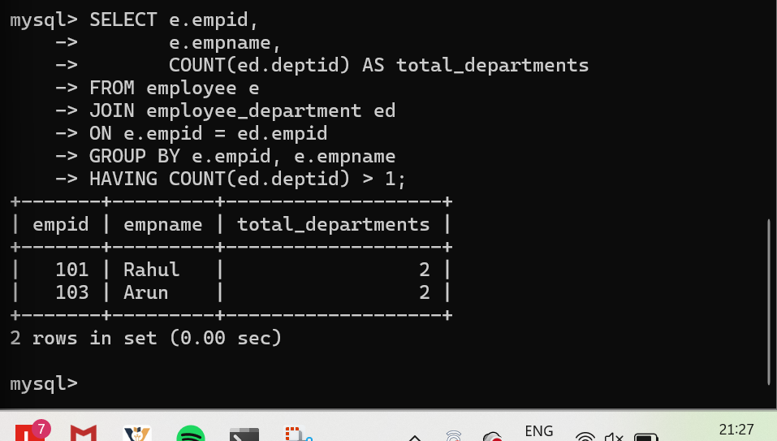

Justification
- JOIN combines the employee and employee_department tables using empid.
- COUNT(deptid) counts how many departments each employee works in.
- GROUP BY groups records by employee.
- HAVING COUNT(deptid) > 1 filters only employees assigned to more than one department.

Conclusion
Using JOIN, GROUP BY, and HAVING is an efficient approach because it accurately identifies employees working in multiple departments while minimizing query complexity and improving readability.
3.
Given Relation :
R(StudentID, StudentName, CourseID, CourseName, Faculty)
Functional Dependencies (FDs) :
StudentID → StudentName
CourseID → CourseName, Faculty

Candidate Key
Since:
- StudentID determines StudentName
- CourseID determines CourseName and Faculty
Neither StudentID nor CourseID alone can determine all attributes.
Therefore, the Candidate Key is:
{StudentID, CourseID}

BCNF Check
A relation is in BCNF if the left side of every functional dependency is a candidate key.
Here,
- StudentID → StudentName (StudentID is not a candidate key)
- CourseID → CourseName, Faculty (CourseID is not a candidate key)
Hence, the relation does not satisfy BCNF.

BCNF Decomposition
Decompose the relation into the following tables:

STUDENT
STUDENT(StudentID, StudentName)

COURSE
COURSE(CourseID, CourseName, Faculty)

ENROLLMENT
ENROLLMENT(StudentID, CourseID)
Final BCNF Relations :
STUDENT(StudentID, StudentName)
COURSE(CourseID, CourseName, Faculty)
ENROLLMENT(StudentID, CourseID)

Conclusion
- Candidate Key: {StudentID, CourseID}
- The original relation is not in BCNF because some functional dependencies have determinants that are not candidate keys.
- Decomposing it into STUDENT, COURSE, and ENROLLMENT removes redundancy, preserves dependencies, and satisfies BCNF.
4.

Create the ACCOUNT Table
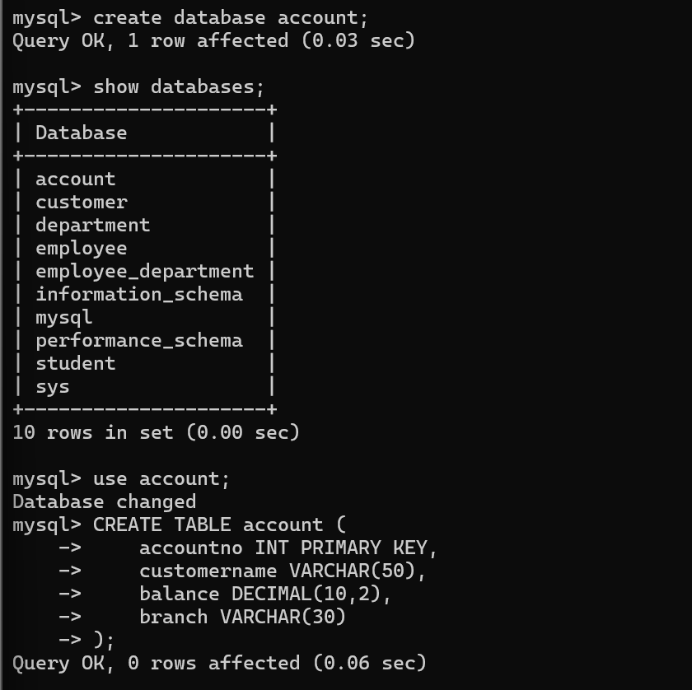

Inserting the Sample Data
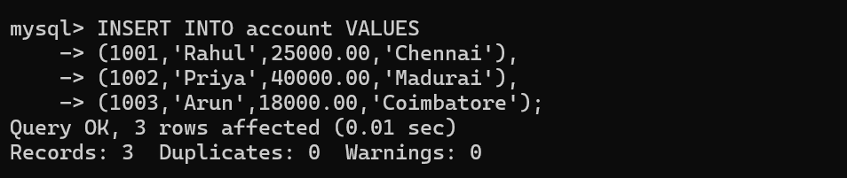

Create a View


Retrieve Data from the View
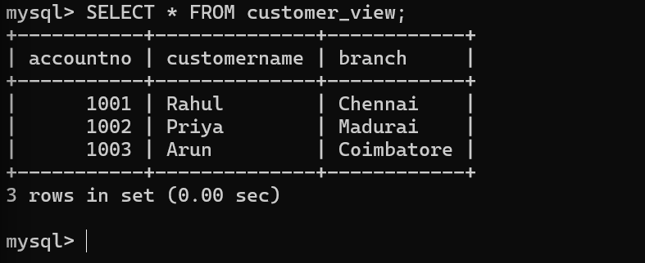Constraints

1. Primary Key
PRIMARY KEY—————> (accountno)
Ensures that every account has a unique account number.

2. NOT NULL Constraint
customername VARCHAR(50) NOT NULL
Prevents customer names from being left empty.

3. CHECK Constraint
CHECK (balance >= 0)
Prevents negative account balances.

4. UNIQUE Constraint
UNIQUE(accountno)
Ensures that no two accounts have the same account number.

Justification
- Views improve security by hiding confidential information such as account balances from unauthorized users.
- Primary Key maintains uniqueness of account records.
- NOT NULL ensures mandatory information is entered.
- CHECK maintains valid account balances.
- UNIQUE prevents duplicate account numbers.

Conclusion
Using Views and Integrity Constraints improves both data security and data integrity, ensuring that different users can access only the information they are authorized to view while maintaining accurate and consistent banking records.
5.
Unnnormalised Relation:
SaleID | CustomerID | CustomerName | ProductID | ProductName | Quantity | Price
S101 | C001 | Rahul | P101 | Laptop | 1 | 50000
S102 | C002 | Priya | P102 | Mouse | 2 | 1000
S103 | C001 | Rahul | P103 | Keyboard | 1 | 2000

Normalization Issues
- Data Redundancy: Customer and product details are repeated.
- Update Anomaly: Updating a customer's name requires changes in multiple rows.
- Insertion Anomaly: A new product cannot be added until it is sold.
- Deletion Anomaly: Deleting the last sale of a product removes its details.

SaleID | CustomerID | CustomerName | ProductID | ProductName | Quantity | Unit Price | SalesPerson
S101 | C001 | Rahul | P101 | Laptop | 1 | 50000 | Arun
S102 | C002 | Priya | P102 | Mouse | 2 | 1000 | Meena
S103 | C001 | Rahul | P103 | Keyboard | 1 | 2000 | Arun

Analyze the Problems :

1. Data Redundancy
- Customer details are repeated for every sale.
- Product details are repeated whenever the product is sold.

2. Update Anomaly
- If the price of a product changes, it must be updated in multiple records.

3. Insertion Anomaly
- A new customer or product cannot be added unless a sale is made.

4. Deletion Anomaly
- If the last sale of a product is deleted, the product information is also lost.

First Normal Form (1NF)
All attributes contain atomic values.
SALES(
SaleID,
CustomerID,
CustomerName,
ProductID,
ProductName,
Quantity,
UnitPrice,
SalesPerson
)

Second Normal Form (2NF)
Separate customer and product details from the sales table.

CUSTOMER
CUSTOMER(
CustomerID,
CustomerName
)

PRODUCT
PRODUCT(
ProductID,
ProductName,
UnitPrice
)

SALES
SALES(
SaleID,
CustomerID,
ProductID,
Quantity,
SalesPerson
)

Step 5: Third Normal Form (3NF)
Remove transitive dependencies by storing salesperson information separately.

CUSTOMER
CUSTOMER(
CustomerID,
CustomerName
)

PRODUCT
PRODUCT(
ProductID,
ProductName,
UnitPrice
)

SALESPERSON
SALESPERSON(
SalesPersonID,
SalesPersonName
)

SALES
SALES(
SaleID,
CustomerID,
ProductID,
SalesPersonID,
Quantity
)

Final 3NF Schema
CUSTOMER(CustomerID, CustomerName)
PRODUCT(ProductID, ProductName, UnitPrice)
SALESPERSON(SalesPersonID, SalesPersonName)
SALES(SaleID, CustomerID, ProductID, SalesPersonID, Quantity)

Advantages of Normalization
- Eliminates data redundancy.
- Removes update, insertion, and deletion anomalies.
- Improves data consistency and integrity.
- Reduces duplicate data storage.
- Makes the database easier to maintain.

Conclusion
- Data redundancy is eliminated.
- Update, insertion, and deletion anomalies are removed.
- Customer, product, and sales information are stored separately.
- The database satisfies Third Normal Form (3NF), resulting in improved consistency, reduced redundancy, and easier maintenance.
6.
Create customer table

Create order table
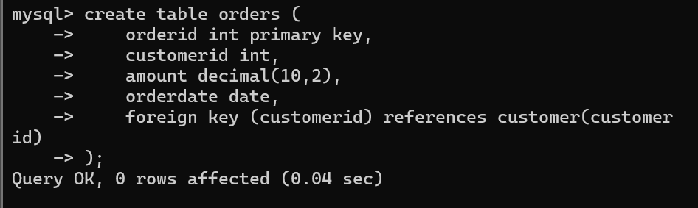
Insert Sample Data
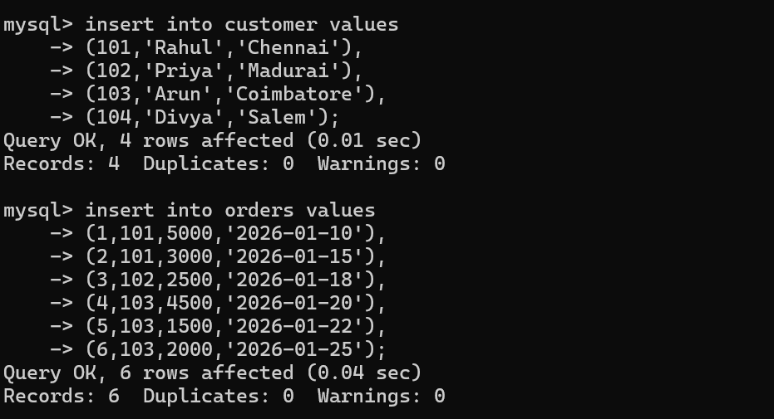

Using JOIN
Display customer names with the number of orders placed.
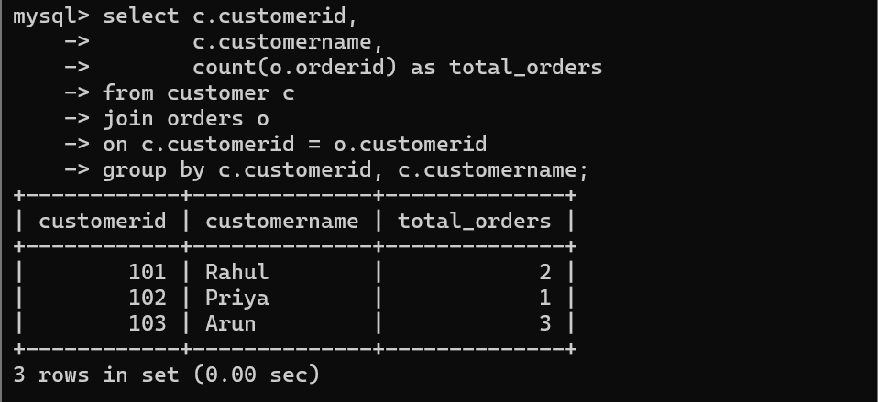

Using Subquery
Display frequent customers (customers who placed more than one order).
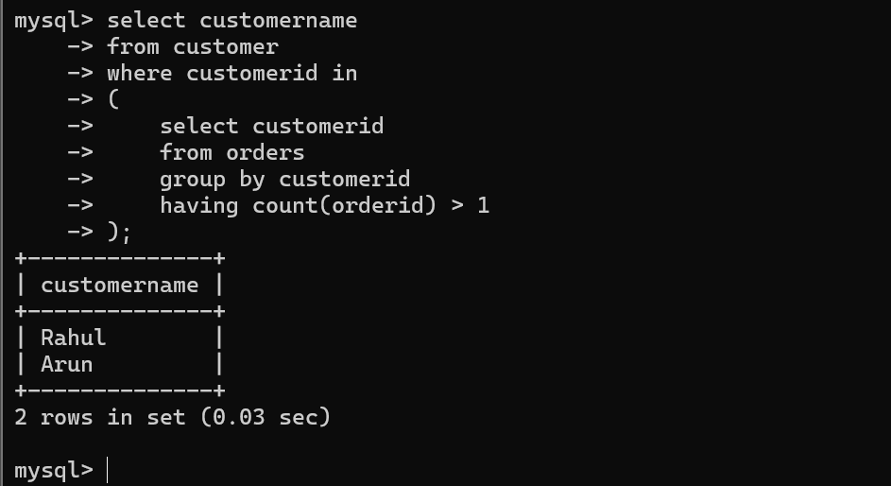

Explanation
- JOIN combines the customer and orders tables to retrieve customer details and their total number of orders.
- COUNT() calculates the number of orders placed by each customer.
- The Subquery identifies customers who have placed more than one order.
- GROUP BY groups the orders by customer.
- HAVING COUNT(orderid) > 1 filters only frequent customers.

Conclusion
- JOIN is suitable for combining data from multiple tables and generating reports.
- Subqueries are useful for filtering records based on aggregated conditions.
- Together, they help identify frequent customers, which is useful for loyalty programs, customer relationship management, and sales analysis.
7.

Given Relation
Suppose a university stores the following information in one table.

STUDENT_SKILL_HOBBY
StudentID | StudentName | Skill | Hobby
101 | Rahul | Java | Cricket
101 | Rahul | Python | Cricket
101 | Rahul | Java | Music
101 | Rahul | Python | Music
102 | Priya | C++ | Dance
102 | Priya | SQL | Dance

Multi-Valued Dependencies
The relation has the following Multi-Valued Dependencies (MVDs):
StudentID →→ Skill

StudentID →→ Hobby
This means:
- A student can have multiple skills.
- A student can have multiple hobbies.
- Skills and hobbies are independent of each other.

Problem
The relation contains redundant data because every skill is combined with every hobby of the same student.
This leads to:
- Data redundancy
- Insertion anomaly
- Deletion anomaly
- Update anomaly

Decompose into 4NF

STUDENT
StudentID | StudentName
101 | Rahul
102 | Priya

STUDENT_SKILL
StudentID | Skill
101 | Java
101 | Python
102 | C++
102 | SQL

STUDENT_HOBBY
StudentID | Hobby
101 | Cricket
101 | Music
102 | Dance

Final 4NF Schema
STUDENT(StudentID, StudentName)
STUDENT_SKILL(StudentID, Skill)
STUDENT_HOBBY(StudentID, Hobby)

Reasoning
- The original relation contained multi-valued dependencies, causing repeated combinations of skills and hobbies.
- By decomposing the relation into separate tables, each independent multi-valued attribute is stored only once.
- This eliminates redundancy and prevents insertion, update, and deletion anomalies.

Conclusion
The original relation does not satisfy Fourth Normal Form (4NF) because it contains multi-valued dependencies. After decomposing it into STUDENT, STUDENT_SKILL, and STUDENT_HOBBY, the database satisfies 4NF, resulting in improved data integrity, reduced redundancy, and easier maintenance.
8.

Improper Schema


Problems in the Schema
- empid is not defined as a primary key, so duplicate employee IDs can occur.
- empname may contain NULL values.
- salary can be entered as a negative value.
- email values may be duplicated.
- There is no validation to ensure valid department values.

Improved Schema with Integrity Constraints
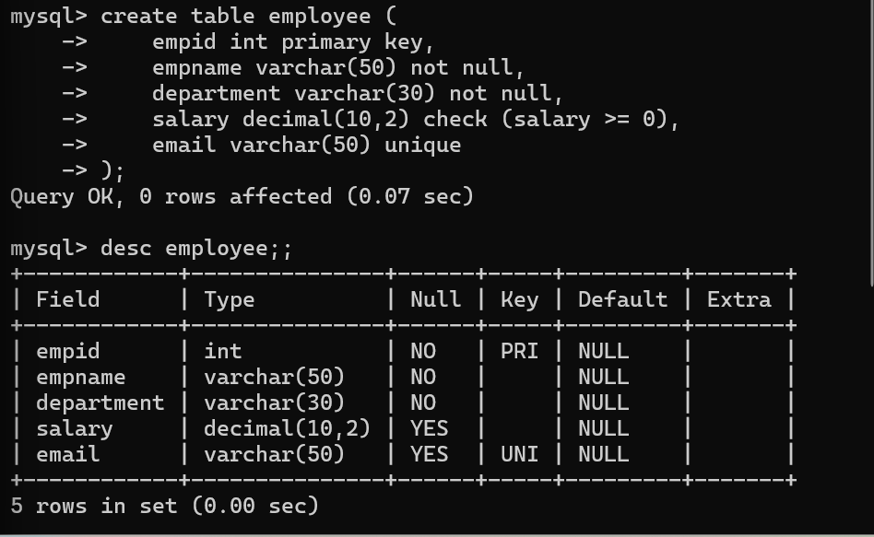

Explanation of Constraints
1. Primary Key
primary key (empid)
- Ensures each employee has a unique ID.
- Prevents duplicate employee records.
2. NOT NULL
empname varchar(50) not null,
department varchar(30) not null
- Ensures mandatory fields cannot be left empty.
3. CHECK Constraint
check (salary >= 0)
- Prevents invalid salary values such as negative amounts.
4. UNIQUE Constraint
email varchar(50) unique
- Ensures each employee has a unique email address.
Advantages
- Prevents duplicate records.
- Ensures mandatory information is entered.
- Maintains valid salary values.
- Prevents duplicate email addresses.
- Improves data consistency and integrity.
Conclusion
By applying Primary Key, NOT NULL, CHECK, and UNIQUE constraints, the schema becomes more reliable and secure. These integrity constraints prevent invalid or inconsistent data from being stored and improve the overall quality of the database.
9.

Given Relation
Consider the following relation:
SupplierID | PartID | ProjectID
S1 | P1 | J1
S1 | P2 | J1
S2 | P1 | J2
S2 | P2 | J2
This relation stores information about:
- Suppliers supplying parts.
- Parts supplied to projects.
- Suppliers working on projects.

Join Dependency
The relation contains the following Join Dependency (JD):
(SupplierID, PartID)
(SupplierID, ProjectID)
(PartID, ProjectID)
The complete relation can be reconstructed by joining these smaller relations.

Problem
The relation contains redundant data because the same supplier, part, and project combinations are repeated.

This causes:
- Data redundancy
- Update anomaly
- Insertion anomaly
- Deletion anomaly
Decompose into 5NF

SUPPLIER_PART
SupplierID | PartID
S1 | P1
S1 | P2
S2 | P1
S2 | P2

SUPPLIER_PROJECT
SupplierID | ProjectID
S1 | J1
S2 | J2

PART_PROJECT
PartID | ProjectID
P1 | J1
P2 | J1
P1 | J2
P2 | J2

Final 5NF Schema
supplier_part(supplierid, partid)
supplier_project(supplierid, projectid)
part_project(partid, projectid)

Explanation
- The original relation contains a join dependency, leading to redundant storage of data.
- By decomposing the relation into three smaller relations, each fact is stored only once.
- The original relation can be reconstructed by joining these three relations without any loss of information.
- This decomposition satisfies Fifth Normal Form (5NF).

Conclusion
The original schema contains join dependencies, which introduce redundancy. Decomposing it into SUPPLIER_PART, SUPPLIER_PROJECT, and PART_PROJECT removes redundancy while preserving all information. The resulting schema satisfies 5NF, ensuring efficient storage, minimal redundancy, and improved data integrity.
10.
Create department Table

Create employee Table
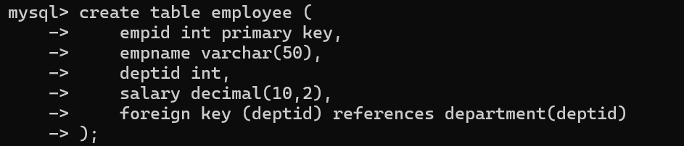
Insert Values
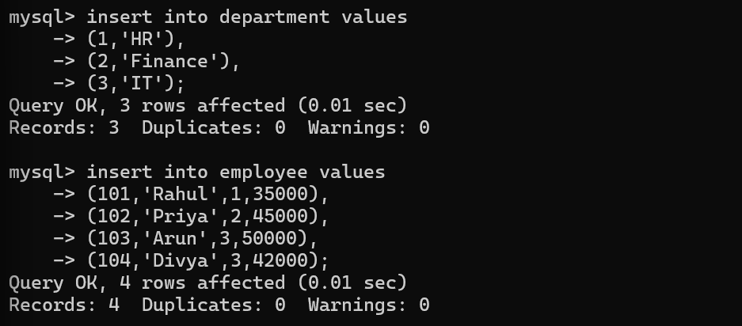
Inefficient Query Using Subquery
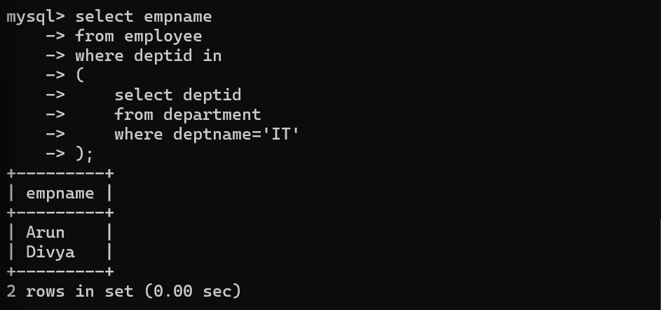

Optimized Query Using JOIN
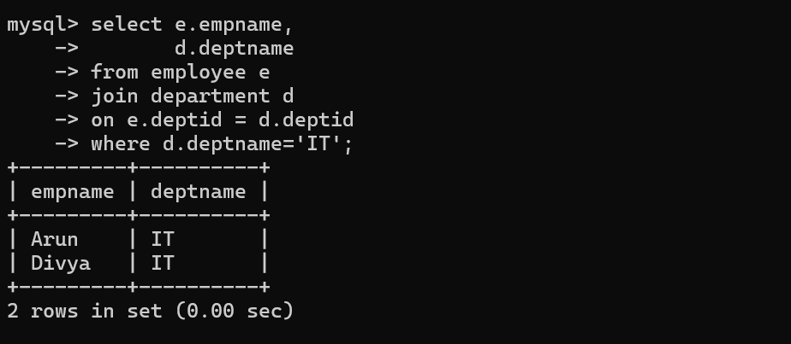
Create an Index:

Create a View
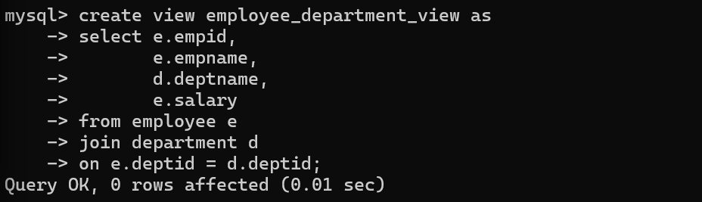
Retrieve data from the view:
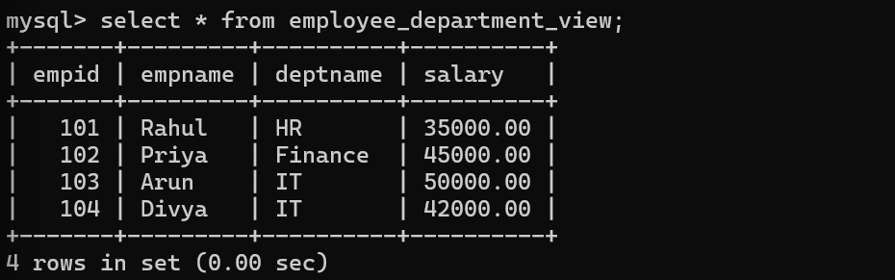
Analysis
Technique | Benefit
JOIN | Faster than subqueries for retrieving related data from multiple tables.
Index | Improves query performance by reducing search time on deptid.
View | Simplifies complex queries and provides reusable, secure access to data.
Conclusion
The inefficient SQL query is optimized by replacing the subquery with a JOIN, creating an index on the deptid column, and using a view for repeated queries. These optimizations reduce execution time, improve performance, and make the database easier to maintain.

